|  |  |  |  |  |  |  |  |  |  |
| --- | --- | --- | --- | --- | --- | --- | --- | --- | --- |
| **SCHOOL OF COMPUTER SCIENCE AND ARTIFICIAL INTELLIGENCE** | | | | | **DEPARTMENT OF COMPUTER SCIENCE ENGINEERING** | | | | |
| **ProgramName:**B. Tech | | | | **Assignment Type: Lab** | | | **AcademicYear:**2025-2026 | | |
| **Course Coordinator Name** | | | | Venkataramana Veeramsetty | | | | | |
| **Instructor(s)Name** | | | | |  | | --- | | Dr. V. Venkataramana (Co-ordinator) | | Dr. T. Sampath Kumar | | Dr. Pramoda Patro | | Dr. Brij Kishor Tiwari | | Dr.J.Ravichander | | Dr. Mohammand Ali Shaik | | Dr. Anirodh Kumar | | Mr. S.Naresh Kumar | | Dr. RAJESH VELPULA | | Mr. Kundhan Kumar | | Ms. Ch.Rajitha | | Mr. M Prakash | | Mr. B.Raju | | Intern 1 (Dharma teja) | | Intern 2 (Sai Prasad) | | Intern 3 (Sowmya) | | NS_2 ( Mounika) | | | | | | |
| **CourseCode** | | | 24CS002PC215 | **CourseTitle** | | AI Assisted Coding | | | |
| **Year/Sem** | | | II/I | **Regulation** | | R24 | | | |
| **Date and Day**  **of Assignment** | | | Week1 - Thursday | **Time(s)** | |  | | | |
| **Duration** | | | 2 Hours | **Applicableto**  **Batches** | | 24CSBTB01 To 24CSBTB39 | | | |
| **AssignmentNumber:1.4**(Present assignment number)/**24**(Total number of assignments) | | | | | | | | | |
|  | | | | | | | | | |
|  | **Q.No.** | **Question** | | | | | | ***ExpectedTime***  ***to complete*** |  |
|  | 1 | Lab 1: Environment Setup – GitHub Copilot and VS Code Integration  **Lab Objectives:**   * To install and configure GitHub Copilot in Visual Studio Code. * To explore AI-assisted code generation using GitHub Copilot. * To analyze the accuracy and effectiveness of Copilot's code suggestions. * To understand prompt-based programming using comments and code context   **Lab Outcomes (LOs):**  After completing this lab, students will be able to:   * Set up GitHub Copilot in VS Code successfully. * Use inline comments and context to generate code with Copilot. * Evaluate AI-generated code for correctness and readability. * Compare code suggestions based on different prompts and programming styles.   **Task Description #1 •** Install and configure GitHub Copilot in VS Code. Take screenshots of each step.  **Expected Output #1 •** Successfully install and activate GitHub Copilot in VS Code. Include screenshots showing installation, authentication via GitHub, and an example suggestion from Copilot**.**  **Task Description #2 •** A function in Python that returns the maximum of three numbers using GitHub Copilot. Use an appropriate comment as a prompt.  **Expected Output #2 •** Python function that takes three inputs and returns the largest value. Include the code and output.  **Task Description #3 •** Use GitHub Copilot to create a recursive Python function that calculates the factorial of a number.  **Expected Output #3 •** Python function for factorial using recursion with input and output examples.  **Task Description #4 •** Prompt GitHub Copilot to create a class named Student with attributes name, roll_no, and marks. Add a method to display student details.  **Expected Output #4 •** Python class definition with an initializer and a display method. Include object creation and output.  **Task Description #5 •** Ask GitHub Copilot to generate a Python function that takes a string as input and returns the frequency of each word.  **Expected Output #5 •** Python function that returns word frequency using a dictionary. Provide sample input and output.  **Note: Report should be submitted a word document for all tasks in a single document with prompts, comments & code explanation, and output and if required, screenshots**  **Evaluation Criteria:**   |  |  | | --- | --- | | **Criteria** | **Max Marks** | | Install and configure GitHub Copilot in VS Code (Task #1) | 0.5 | | Python function that takes three inputs and returns the largest value (Task #2) | 0.5 | | Python function for factorial using recursion (Task #3) | 0.5 | | Python class definition with an initializer and a display method (Task #4) | 0.5 | | Function that returns word frequency using a dictionary (Task #5) | 0.5 | | **Total** | **2.5 Marks** | | | | | | | Week1 - Thursday |  |

**Task Description #2  
•** A function in Python that returns the maximum of three numbers using GitHub Copilot. Use an appropriate comment as a prompt.

Prompt:

Write a python code using functions to find greatest of three numbers.

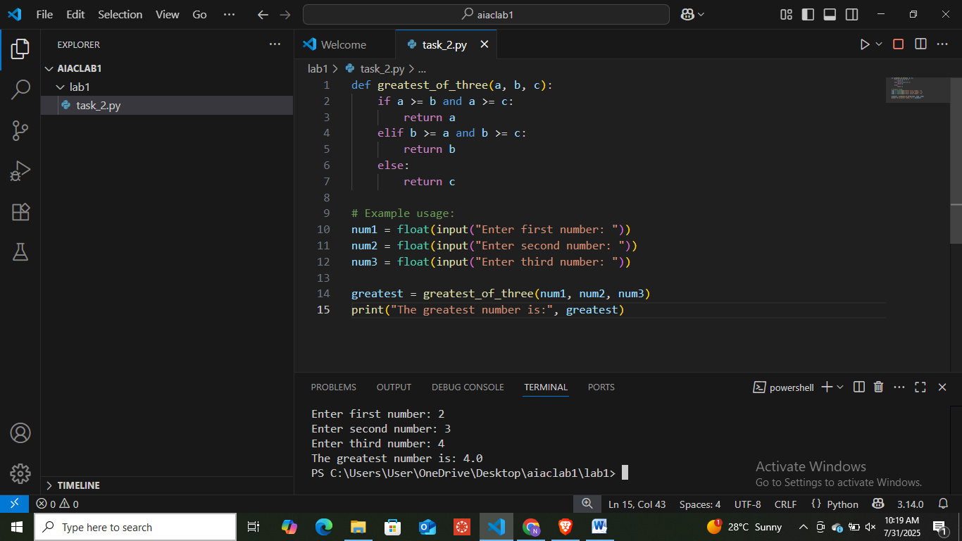

**Task Description #3  
•** Use GitHub Copilot to create a recursive Python function that calculates the factorial of a number.

Prompt:

Write a python code using function by creating recursive function that calculate the factorial of given number.

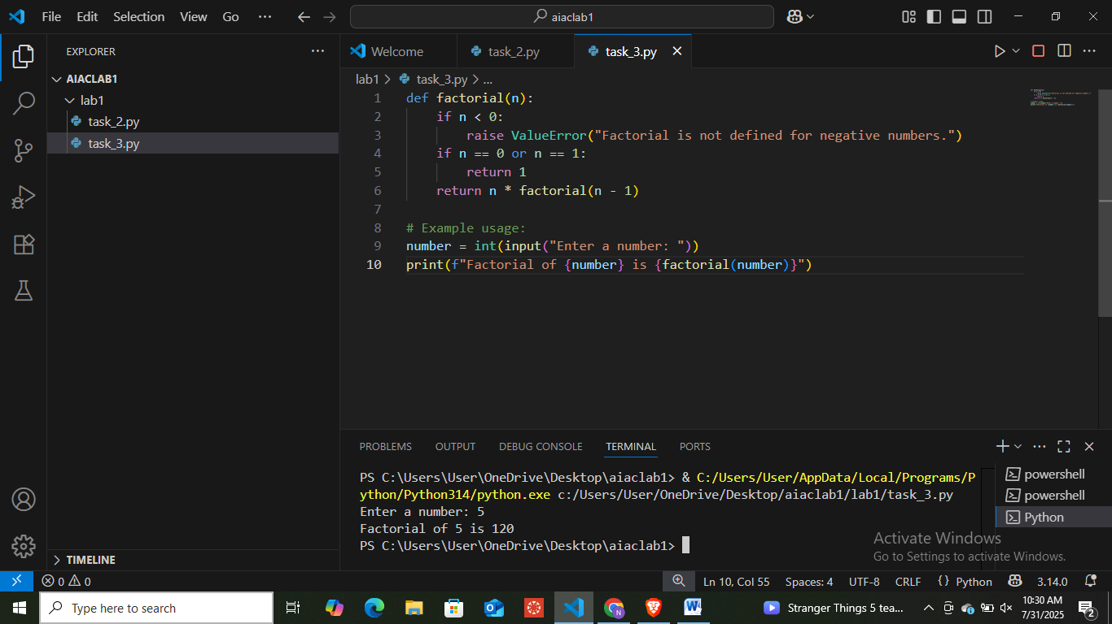

**Task Description #4  
•** Prompt GitHub Copilot to create a class named Student with attributes name, roll_no, and marks. Add a method to display student details.

Prompt:

Write a python code to display class named Student details using the attributes like name,roll no and marks

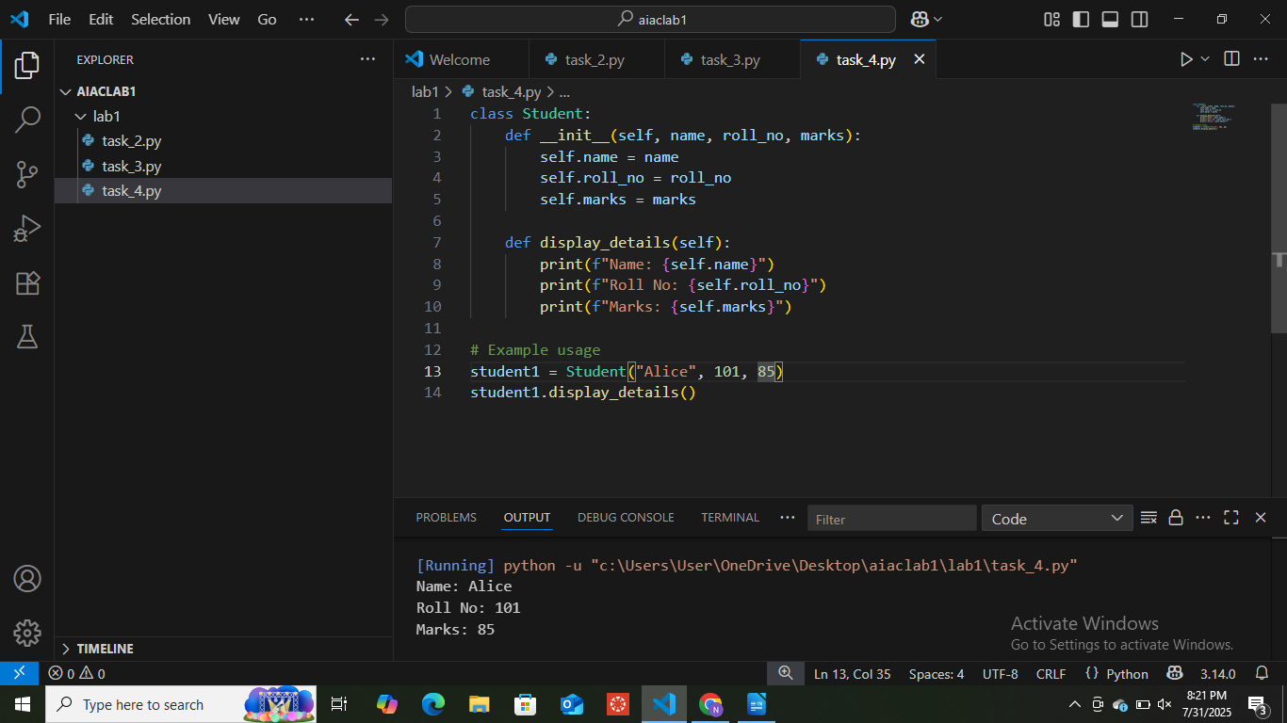

**Task Description #5  
•** Ask GitHub Copilot to generate a Python function that takes a string as input and returns the frequency of each word.

Prompt:

Write a python code by using function that takes a string as input from user and returns the frequency of each word.

